# Summary

In our serious game we want to learn the player about what is going on a daily basis, on the small air base of Ireland. At first you start with a wide view of the whole base, here you can see the main building were all the personal works, the landing stripes, the helipads and the hangers. In this wide view you can see which planes/helicopters are landing or taking off. The task at hand is to make sure runway is clear and the right crew is at the right location. To control the crew the player has to tap on the hanger/personal area to zoom in on that location where you are able to control all the personal.

# Controls

## Zoom in

You can zoom in on the hanger area by tapping on that site.

## zoom out

Pinch fingers to zoom out from the hanger site.

## guide planes

Start dragging on a plane that you want to give a different course and maybe land.

## plan personal

Zoom into the hanger site and tab on a building you want to use. After tapping the building a small menu comes up and you can choose what the personal has to do.

# design

## map

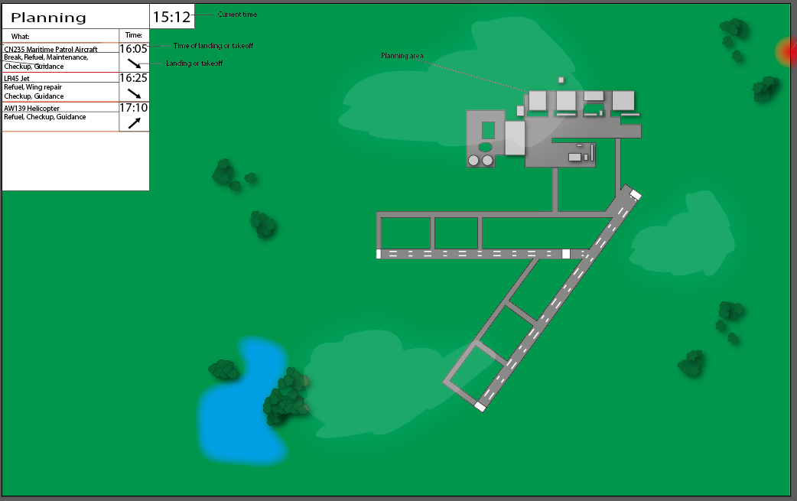

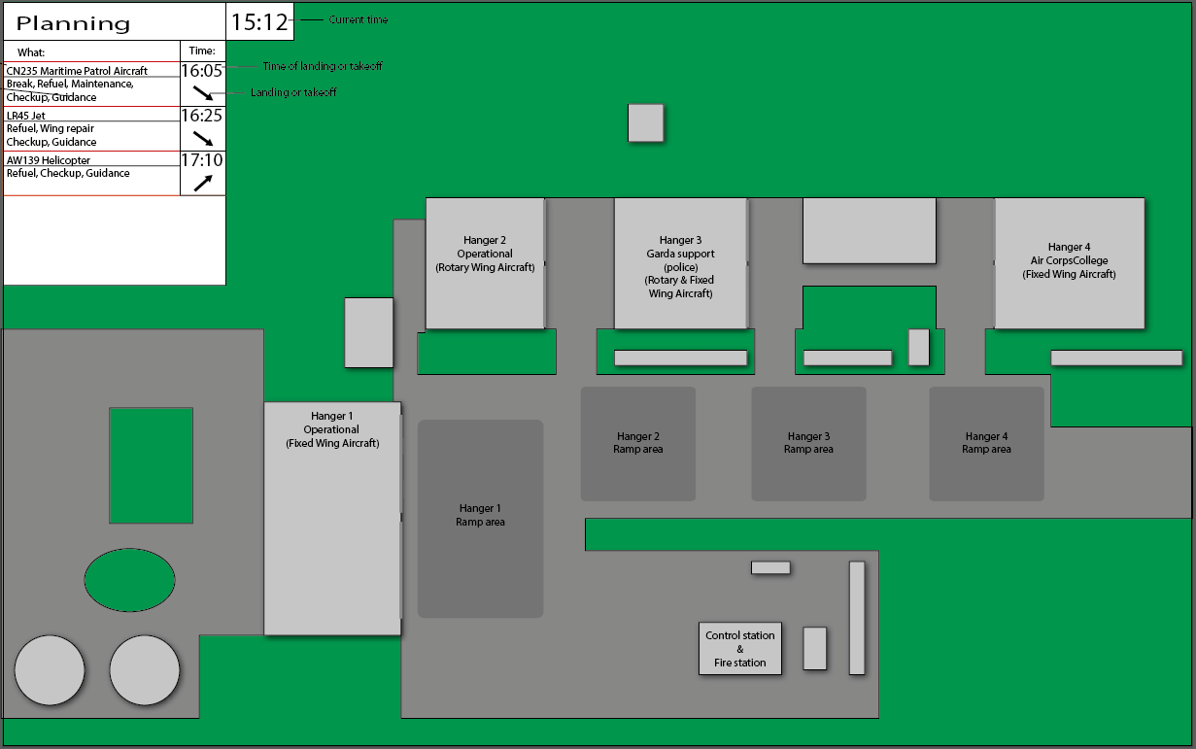

## planes/helicopters

### LR45

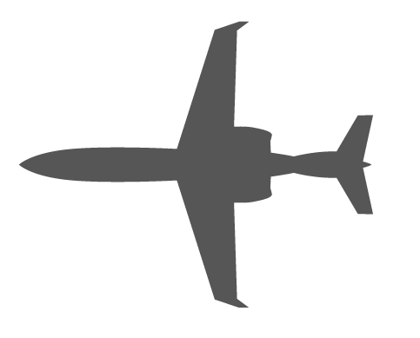

# events